LAB MANUAL

Computer Network Lab

Exp. No | Practical to be covered | Mapped to CO
1 | Apply basic concepts of networking to demonstrate Ethernet cabling and connections of RJ45 and Cat6. | CO3
2 | Use basic networking commands in Linux/Windows (ping, tracert, nslookup, netstat, ARP,RARP, ip, ifconfig, dig, route,nmap ) | CO1
3 | Use simulation tool Wire shark to analyze network traffic. | CO2
4 | Implement error detection method such as CRC, Checksum. | CO4
5 | Build a simple network topology and configure it for static routing protocol using packet tracer | CO2
6 | Set up multiple IP addresses on a single LAN. | CO1
7 | Using nestat and route commands of Linux, do the following:  View current routing table  Add and delete routes  Change default gateway | CO3
8 | Design VPN and configure RIP/OSPF using packet tracer. | CO4
9 | Write a program to implement Socket programming using TCP. | CO4
10 | Perform Remote login using Telnet server | CO4

CELC 405
Computer Network Lab
Course Objective
1 | To Guide in using network simulation tools
2 | To facilitate in developing the topological and routing strategies for an IP based networking  Infrastructure.
3 | To guide in exploring various issues of packet transfer from source to destination and resolve them.
Course Outcome: Learner will be able to
CELC405.1 | Design and setup networking environment in Linux.
CELC405.2 | Use Network tools and simulators such as NS2, Wireshark etc. to explore networking algorithms and protocols.
CELC405.3 | Setup and configure network connections.
CELC405.4 | Implement programs using core programming APIs for understanding networking concepts.

PRACTICAL 1

AIM: Use of Crimping Tool for RJ45.

THEORY: Crimping an RJ45 Connector Correctly Proper Wiring for Ethernet Cat5/Cat5e/Cat
6 Cables


- Cables can transmit information along their length. To actually get that information where it needs to go, you need to make the right connections to an RJ45 connector.

- Your cable run needs to terminate into a connector, and that connector needs a jack to plug into.

- Registered Jack 45 (RJ45) is a standard type of physical connector for network cables. RJ45 connectors are commonly seen with Ethernet cables and networks.

- Modern Ethernet cables feature a small plastic plug on each end of the cable. That plug is inserted into RJ45 jacks of Ethernet devices. The term “plug” refers to the cable or “male” end of the connection while the term “jack” refers to the port or “female” end.

T568A or T568B Wiring Standard:
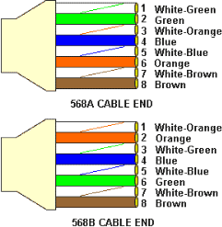

- T568A and T568B are the two colour codes used for wiring eight-position modular plugs. Both are allowed under the ANSI/TIA/EIA wiring standards. The only difference between the two color codes is that the orange and green pairs are interchanged.
- There is no transmission differences between T568A and T568B cabling schemes. North America’s preference is for T568B. Both ends must use the same standard. It makes no difference to the transmission characteristics of data.

  - T568B wiring pattern is recognized as the preferred wiring pattern.

STEP 1:

Using a Crimping Tool, trim the end of the cable you're terminating, to ensure that the ends of the condu wires are even.



STEP 2:

Being careful not to damage the inner conducting wires, strip off approximately 1 inch of the cable's jacket, using a modular crimping tool or a UTP cable stripper.

STEP 3:

Separate the 4 twisted wire pairs from each other, and then unwind each pair, so that you end up with 8 individual wires. Flatten the wires out as much as possible, since they'll need to be very straight for proper insertion into the connector.



STEP 4:

Holding the cable with the wire ends facing away from you. Moving from left to right, arrange the wires in a flat, side-by-side ribbon formation, placing them in the following order: white/orange, solid orange, white/green, solid blue, white/blue, solid green, white/brown, solid brown.

STEP 5:

Holding the RJ45 connector so that its pins are facing away from you and the plug-clip side is facing down, carefully insert the flattened, arranged wires into the connector, pushing through until the wire ends emerge from the pins. For strength of connection, also push as much of the cable jacket as possible into the connector.

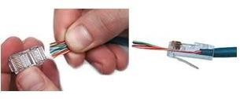

STEP 6:

Check to make sure that the wire ends coming out of the connector's pin side are in the correct order; if not, remove them from the connector, rearrange into proper formation, and re-insert. Remember, once the connector is crimped onto the cable, it's permanent. If you realize that a mistake has been made in wire order after termination, you'll have to cut the connector off and start all over again!



STEP 7: Insert the prepared connector/cable assembly into the RJ45 slot in your crimping tool. Firmly squeeze the crimper's handles together until you can't go any further. Release the handles and repeat this step
to ensure a proper crimp.



STEP 8:

If your crimper doesn't automatically trim the wire ends upon termination, carefully cut wire ends to make them as flush with the connector's surface as possible. The closer the wire ends are trimmed, the better your final plug-in connection will be.



STEP 9:
After the first termination is complete, repeat process on the opposite end of your cable



CONCLUSION: Thus, we have studied the use of crimping tool for RJ-45.

PRACTICAL 2
AIM: Use basic networking commands in Linux (ping, tracert, nslookup, netstat, ARP, RARP, ip, ifconfig, dig, route )

THEORY:

ifconfig
ifconfig(interface configuration) command is used to configure the kernel-resident network interfaces. It is used at the boot time to set up the interfaces as necessary. After that, it is usually used when needed during debugging or when you need system tuning. Also, this command is used to assign the IP address and netmask to an interface or to enable or disable a given interface.
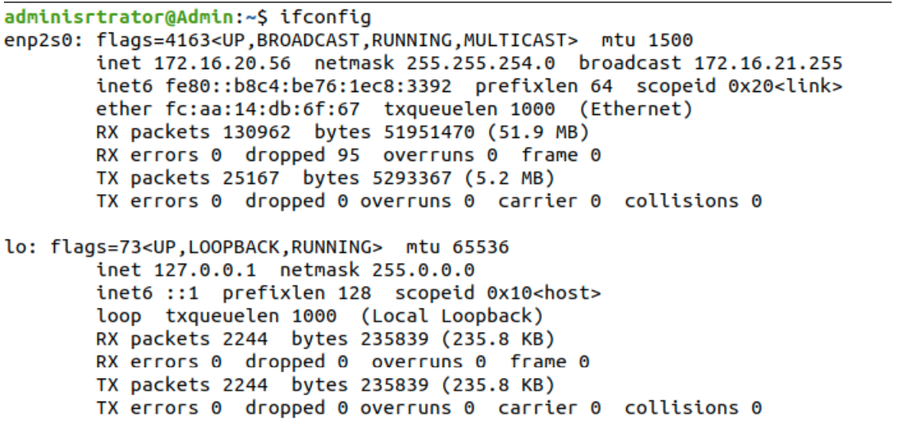

NSLOOKUP
Nslookup (stands for “Name Server Lookup”) is a useful command for getting information from DNS server. It is a network administration tool for querying the Domain Name System (DNS) to obtain domain name or IP address mapping or any other specific DNS record. It is also used to troubleshoot DNS related problems.

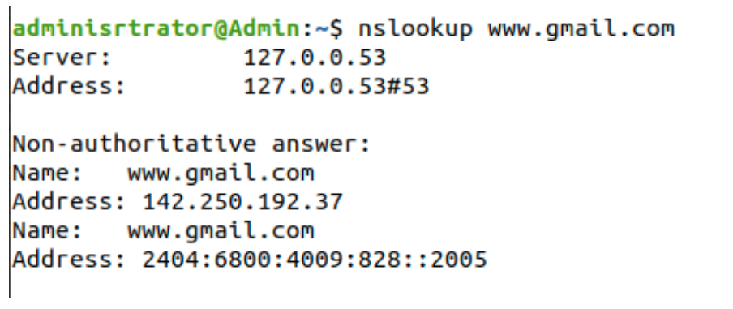

Ping

PING (Packet Internet Groper) command is used to check the network connectivity
between host and server/host. This command takes as input the IP address or the URL and sends a data packet to the specified address with the message “PING” and get a response from the server/host this time is recorded which is called latency. Fast ping low latency means faster connection. Ping uses ICMP(Internet Control Message Protocol) to send an ICMP echo
message to the specified host if that host is available then it sends ICMP reply message. Ping is generally measured in millisecond every modern operating system has this ping pre-installed.

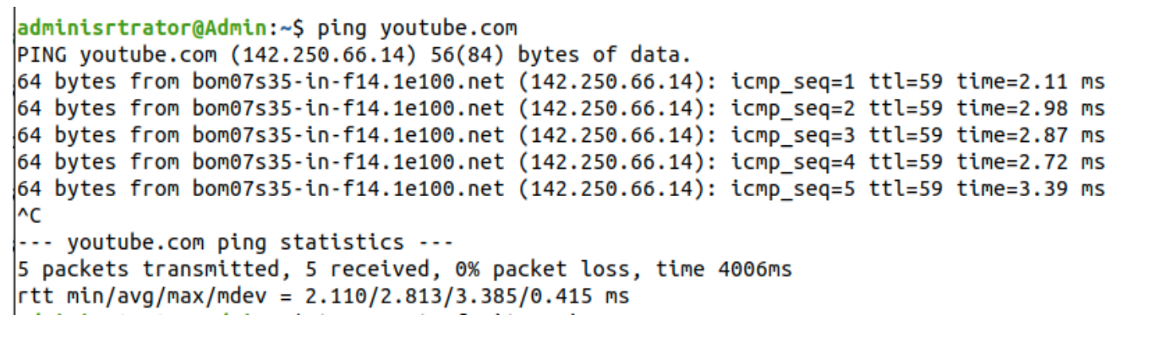

TRACEROUTE
traceroute command in Linux prints the route that a packet takes to reach the host. This command is useful when you want to know about the route and about all the hops that a packet takes. Below image depicts how traceroute command is used to reach the Google(172.217.26.206) host from the local machine and it also prints detail about all the hops that it visits in between.

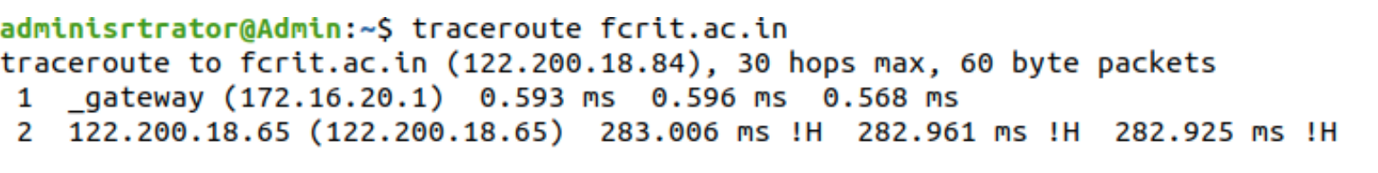

Netstat
Netstat command displays various network related information such as network connections, routing tables, interface statistics, masquerade connections, multicast memberships etc.,
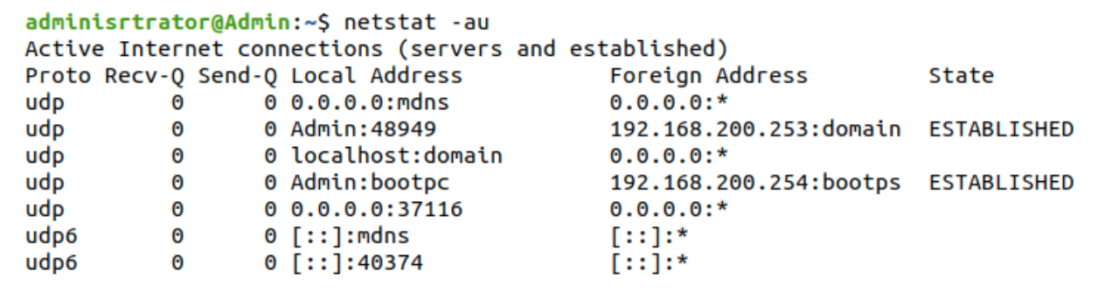

ARP

ARP command manipulates the System’s ARP cache. It also allows a complete dump of the ARP cache. ARP stands for Address Resolution Protocol. The primary function of this protocol is to resolve the IP address of a system to its mac address, and hence it works between level 2(Data link layer) and level 3(Network layer).

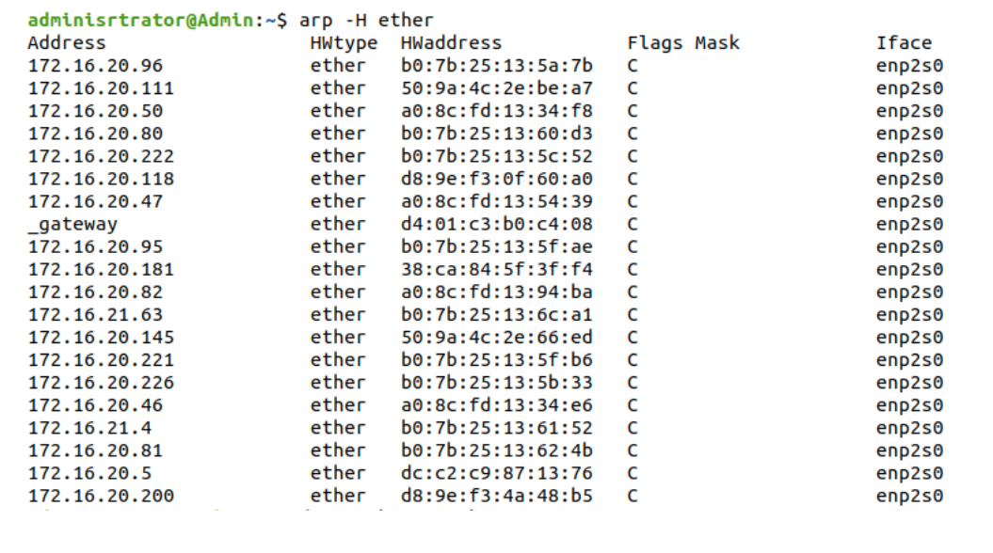

Dig
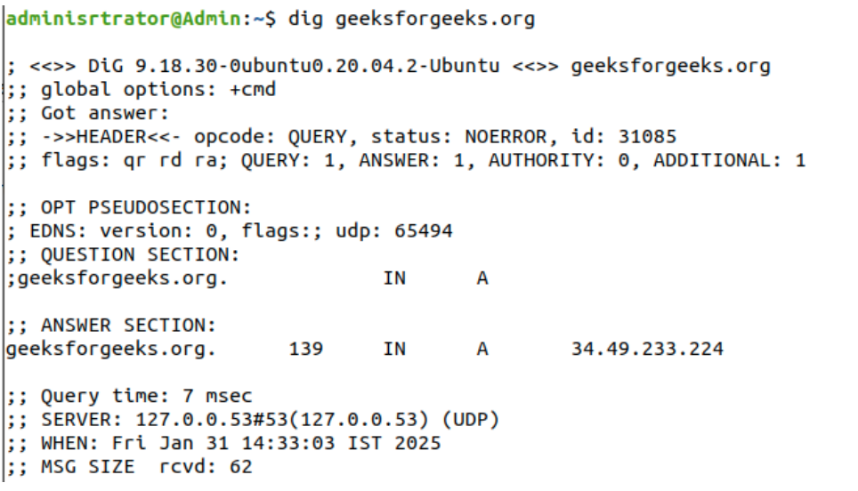dig command stands for Domain Information Groper. It is used for retrieving information
about DNS name servers. It is basically used by network administrators. It is used for verifying and troubleshooting DNS problems and to perform DNS lookups. Dig command replaces older tools such as nslookup and the host.

- RARP:
Reverse Address Resolution Protocol (RARP) is a network protocol that allows a device to discover its IP address when only its MAC (Media Access Control) address is known. It was designed for systems such as diskless workstations, which do not have permanent storage to save their IP addresses. These devices boot from ROM and must request their IP address dynamically from a RARP server on the local network.
- Ip:
The ip command in Linux is used to configure and manage network interfaces, IP addresses, and routing. It is part of the iproute2 package and replaces older networking tools like ifconfig and route.
- Displays and manages IP addresses and network interfaces.
- Used to configure routing tables and network rules.
- Supports both IPv4 and IPv6 networking.
- Provides detailed and real-time network information.

- Route:
This command helps you view, add, or delete routes for specific destinations, whether to a single host or an entire network. You can define these routes using either numeric IP addresses or symbolic names. The system then uses /etc/hosts or a name server to resolve these names.
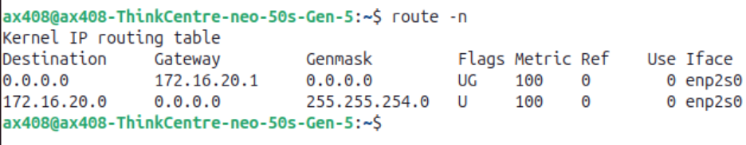

- Nmap
nmap is a powerful open-source command-line tool used for network discovery, security auditing, and identifying open ports on local or remote systems.
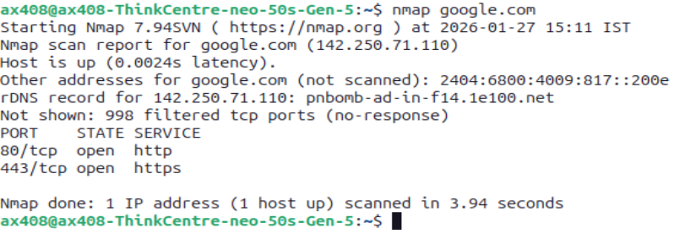

CONCLUSION: Hence, in this Practical, we have successfully studied some important networking command and also implemented them in Linux

PRACTICAL 3
AIM: Use Simulation tool Wireshark to analyze network traffic

THEORY: Wireshark is a network protocol analyzer (or packet sniffer) used to capture and interactively browse the traffic running on a computer network. It’s widely used for network troubleshooting, analysis, software and protocol development, and education.
Here’s a shorter version of your theory:

🧪 Wireshark – TCP/IP & Protocol Analysis (Short Theory)
Wireshark is a network packet analyzer used to capture and study data packets in real time. It helps understand how the TCP/IP model works and how different protocols communicate.
🌐 TCP/IP Layers Observed:
- Application → HTTP, DNS, FTP
- Transport → TCP, UDP
- Internet → IP, ICMP
- Network Access → ARP, Ethernet
Wireshark shows packet details like source/destination IP, protocol, length, and data.
🔎 (a) Protocol Filtering:
Filters help isolate traffic:
- http → HTTP traffic
- tcp → TCP packets
- udp → UDP packets
- arp → ARP requests
- icmp → ping messages
👉 Used for debugging and analyzing specific protocols.
🔐 (b) HTTP Password Detection:
In HTTP (non-secure) sites, login data is sent in plain text and can be viewed in Wireshark:
Example:
txtUsername=abcd&txtPassword=abc@123
👉 This shows HTTP is insecure because data is not encrypted. HTTPS is safer.
📡 Conclusion:
Wireshark helps analyze network behavior, study protocols, and detect security issues like plaintext data exposure in HTTP.

PROCEDURE:

- Download and install Wireshark from the official website: https://www.wireshark.org/. Follow the on-screen instructions to complete the installation.

- Open Wireshark after installation.

- Select a network interface by clicking on "Capture" → "Options" or choosing the network adapter from the main screen. Choose the correct network interface:

- Wi-Fi if you're on a wireless network.

- Ethernet if using a wired connection.

- Start capturing traffic by clicking the "Start" button or pressing Ctrl + E.

- Generate network traffic by opening a browser, visiting a website, or using an application.

- Stop the capture by clicking the "Stop" button or pressing Ctrl + E again when you have enough data.

- Analyze the captured packets using the filter bar. Some useful filters include:

- http to view HTTP traffic

- tcp.port == 80 to filter TCP traffic on port 80

- ip.addr == 192.168.1.1 to view traffic related to a specific IP

- Save the capture if needed by clicking "File" → "Save As" to store the captured packets for later analysis.

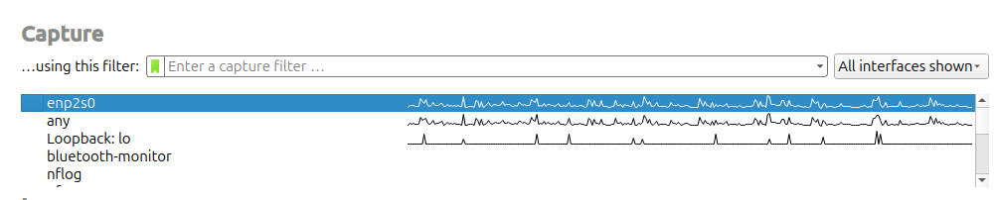

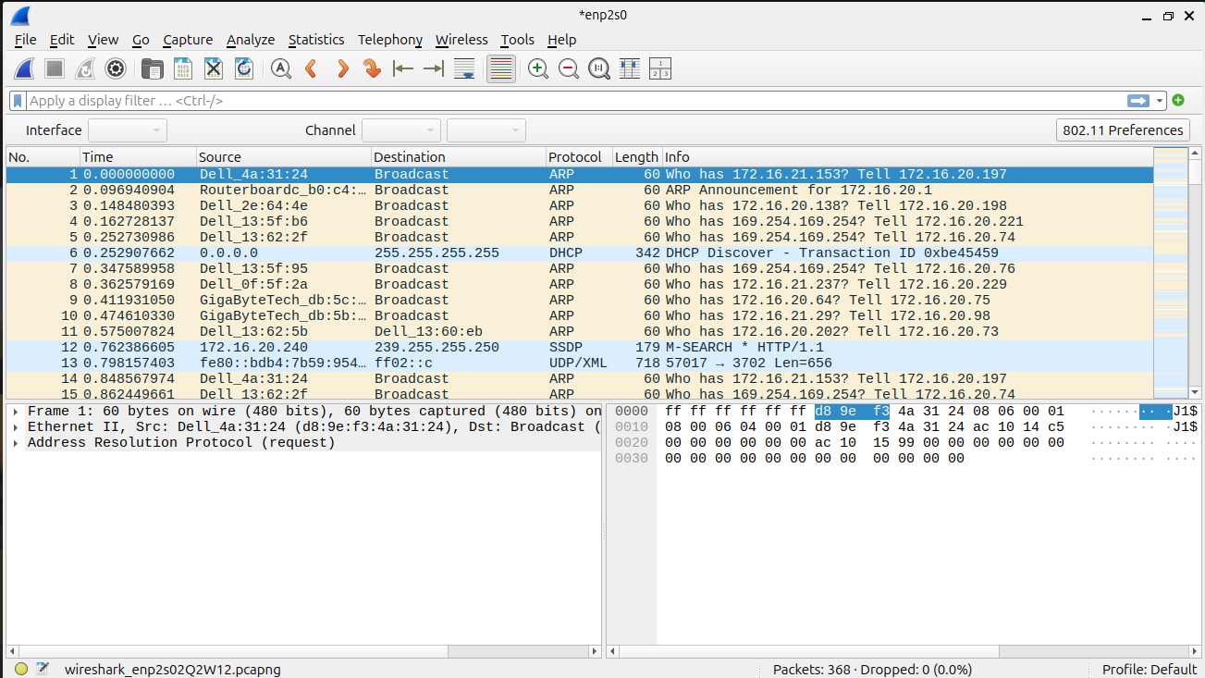

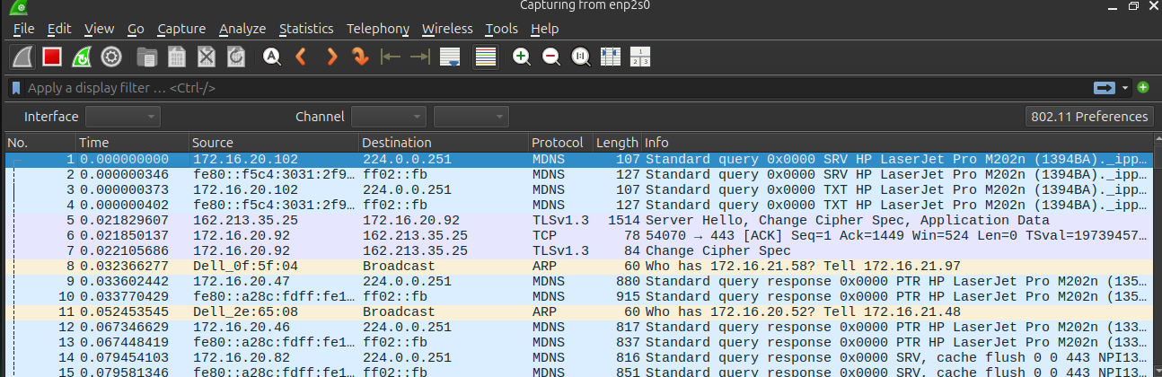

FOR PASSWORD DETECTION:
Visit: http://vbsca.ca/login/login.asp
Login using any username /pass
go to wireshark
in filter type http or http.request.method == "POST"
Then look for : POST/login
Then: Right click → Follow → TCP Stream

CONCLUSION: Using Wireshark, we successfully captured and analyzed network traffic in real-time. By applying filters, we could inspect specific packets, helping us understand data flow and troubleshoot network issues efficiently. This practical exercise demonstrates how Wireshark is a valuable tool for network monitoring and security analysis.


Practical 5

AIM: Build a simple network topology and configure for static routing protocol using packet tracer.

PROCEDURE:
Steps to Build a Simple Network Topology in Cisco Packet Tracer

- Open Cisco Packet Tracer and launch a new workspace.
- Add network devices by dragging and dropping the required devices, such as routers, switches, and PCs, from the network devices section. For a basic topology, add one switch and two PCs.
- Connect devices using cables. Select the "Connections" tool and use copper straight-through cables to connect PCs to the switch. If connecting routers to switches, use copper cross-over cables.
- Assign IP addresses to PCs by clicking on a PC, navigating to the "Desktop" tab, and selecting "IP Configuration." Assign an IP address (for example, PC1: 192.168.1.2, PC2: 192.168.1.3) and set the subnet mask to 255.255.255.0.
- Test network connectivity by opening the command prompt on a PC, then using the ping command (for example, ping 192.168.1.3) to check communication between devices.
- Save your work by clicking "File" and selecting "Save As" to store your network topology.

Sample Outputs:

  - Bus Topology
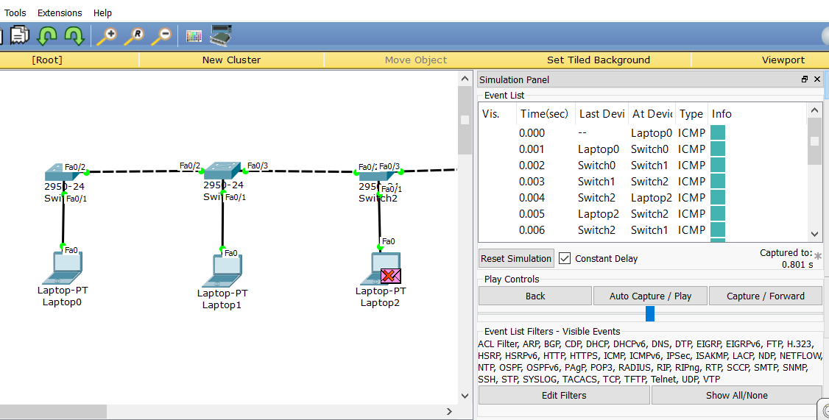

  - Star Topology :
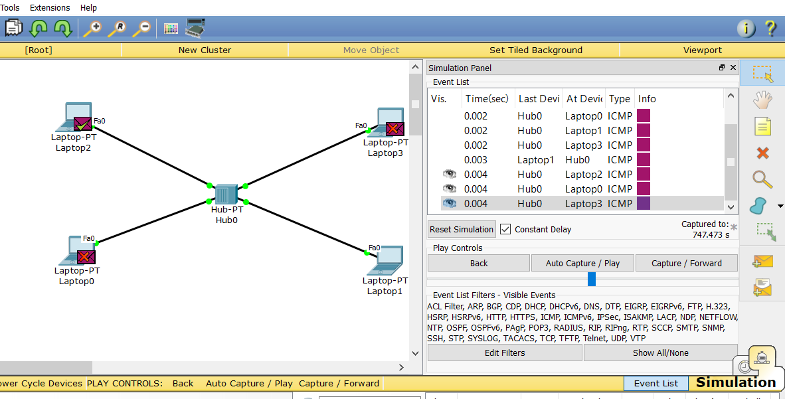

3.Mesh topology: 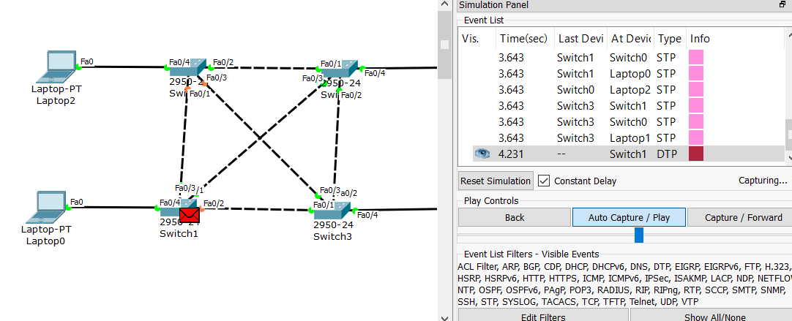

  - Ring topology :
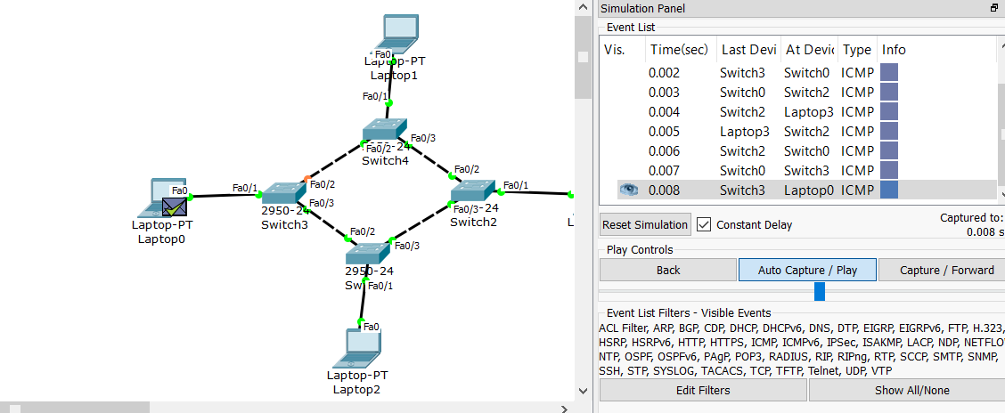

CONCLUSION: By following these steps, we successfully built a simple network topology in Cisco Packet Tracer. The devices were connected, assigned IP addresses, and tested for connectivity using the ping command. This practical exercise demonstrates how basic networking concepts, such as device communication and IP addressing, can be implemented and tested in a simulated environment.

Practical 6:
AIM: Set up multiple IP addresses on a single LAN.

Theory:
First, let us find the IP address of the network card. In my Ubuntu 15.10 server, I use only one network card.
Here’s a clean, shorter, lab-ready version of your experiment:

🧪 AIM:
To set up multiple IP addresses on a single LAN.

📖 THEORY:
A single network interface can have multiple IP addresses. This is useful for testing, segmentation, and hosting multiple services on one machine.
In Ubuntu, network interfaces can be configured using commands like ifconfig or ip.
To check current IP configuration:
sudo ifconfig
or
ip addr

⚙️ COMMAND (Add Multiple IP Address):
sudo ip addr add 172.16.20.232/24 dev enp2s0
📌 Meaning:
- Adds a secondary IP address 172.16.20.232
- Subnet mask /24
- Applied to interface enp2s0

🖥️ OUTPUT:
- Running sudo ifconfig or ip addr will show:
  - Existing IP address
  - Newly added secondary IP address
  - Network interface details (MAC, netmask, etc.)

🎯 CONCLUSION:
Setting multiple IP addresses on a single LAN enables efficient network usage, better segmentation, and flexible testing environments. It is commonly used in servers, virtual labs, and network simulations.

Run the following command to find out the IP address:
sudo ifconfig
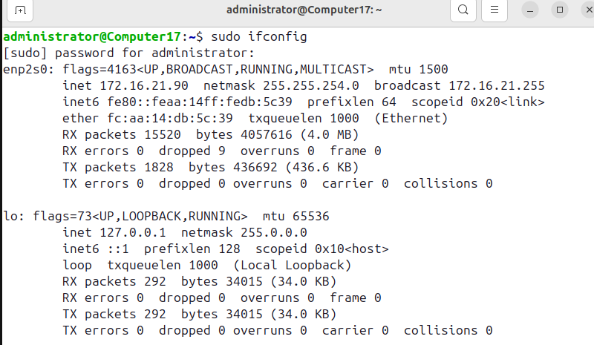

COMMAND sudo ip addr add 172.16.20.232/24 dev enp2s0 This command will add the IP address 172.16.20.232 to the enp2s0 network interface
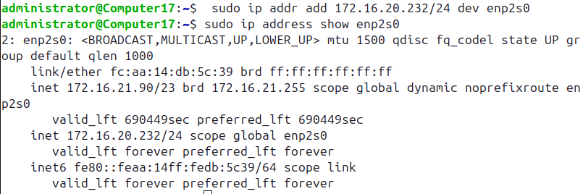

Command -sudo ifconfig
OUTPUT This command will display all the network interfaces and their current settings, such as IP addresses, netmasks, and more.

COMMAND sudo ip addr add 172.16.20.232/24 dev enp2s0 This command will add the IP address 172.16.20.232 to the enp2s0 network interface 

CONCLUSION: Setting up multiple IP addresses on a single LAN allows for better network segmentation, improved traffic management, and enhanced security. By using methods such as secondary IP addresses, subnetting, VLANs, and routing, different devices can communicate efficiently within the same physical network. This approach is useful in scenarios like server hosting, multi-network communication, and testing environments.

Practical 7

AIM:
Using nestat and route commands of Linux, do the following:

      - View current routing table
      - Add and delete routes
      - Change default gateway

Procedure / Commands:
Command: nestat -rn
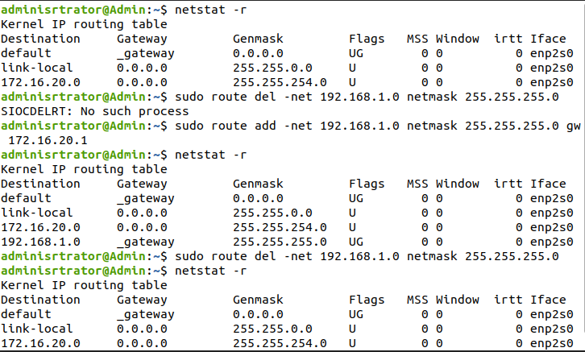
Adding route
sudo route add -net 192.168.3.0 gw 192.168.1.1 netmask 255.255.255.0 dev eth0
Deleting route
sudo route del -net 192.168.3.0 gw 192.168.1.1 netmask 255.255.255.0 dev eth0
A quick way to add default route
route add default gw 192.168.1.1
A quick way to delete defualt route

route del default gw 192.168.1.1

CONCLUSION: Thus, we have studied and successfully add the multiple IP address and also perform actions in Linux

Practical 8
AIM: Design VPN and Configure RIP/OSPF using Packet tracer.

THEORY:

Routing Information Protocol (RIP) is a dynamic routing protocol which uses hop count as a routing metric to find the best path between the source and the destination network. It is a distance vector routing protocol which has AD value 120 and works on the application layer of OSI model. RIP uses port number 520.

Hop Count:
Hop count is the number of routers occurring in between the source and destination network. The path with the lowest hop count is considered as the best route to reach a network and therefore placed in the routing table. RIP prevents routing loops by limiting the number of hopes allowed in a path from source and destination. The maximum hop count allowed for RIP is 15 and hop count of 16 is considered as network unreachable.

Features of RIP:
- Updates of the network are exchangedperiodically.
- Updates (routing information) are always broadcast.
- Full routing tables are sent in updates.
- Routers always trust on routing information received from neighbour routers. This is also known as Routing on rumours.
Steps for implementing RIP

Step1:
Select Router – select 1841 router and drag it to the screen (Router0).
Select another Router – select 1841 and drag it to right of the Router0 (Router1). Select Switches – select 2950-24 and drag it below the Router0 (Switch0).
Select Switches – select 2950-24 and drag it below the Router1 (Switch1). Select End Device – select Generic and drag it below Switch0 (PC-PT PC0). Select End Device – select Generic and drag it below Switch1 (PC-PT PC1). Select End Device – select Generic and drag it below Switch1 (PC-PT PC2). Select Connections – Connect routers, switches and PCs to each other.

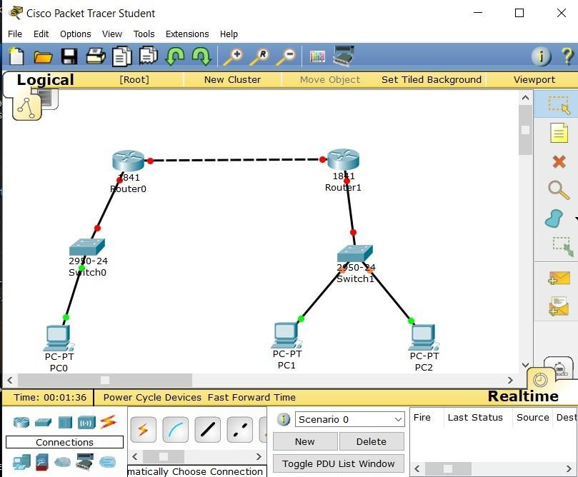

Step 2:
Click on PC0 and go to Desktop > IP Configuration
Add IP Address, as you will add the IP Address, Subnet Mask will be automatically added and displayed.
Add Default Gateway and close the window.
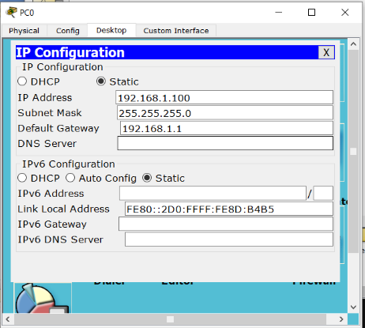

Step 3:
Click on PC1 and go to Desktop > IP Configuration
Add IP Address, as you will add the IP Address, Subnet Mask will be automatically added and displayed.
Add Default Gateway and close the window.
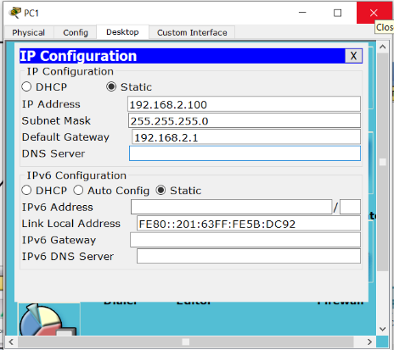

Step 4:
Click on PC2 and go to Desktop > IP Configuration
Add IP Address, as you will add the IP Address, Subnet Mask will be automatically added and displayed.
Add Default Gateway and close the window.
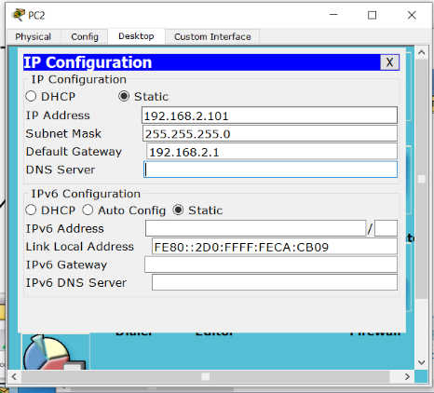

Step 5:
Click on Router0. Go to Config > FastEthernet0/0. Here, add IP Address and On the Port Status.

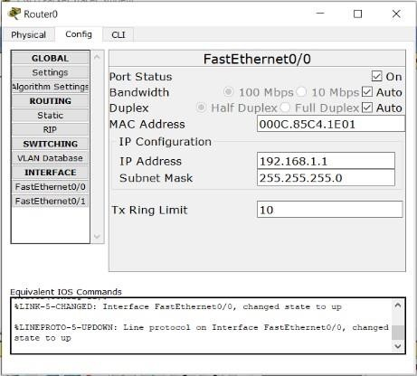

Step 6:
Click on Router1. Go to Config > FastEthernet0/1. Here, add IP Address and On the Port Status.
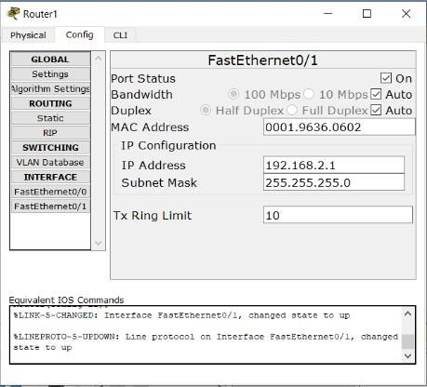
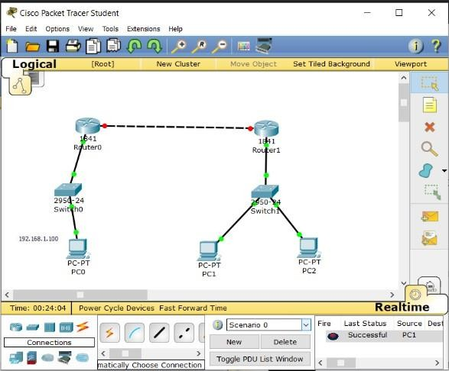

As you will see above, there is green dots which means connections are done successfully between Router, Switches and PCs.

Step 7:
Click on Router0. Go to Config > FastEthernet0/1. Here, add IP Address and On the Port Status.
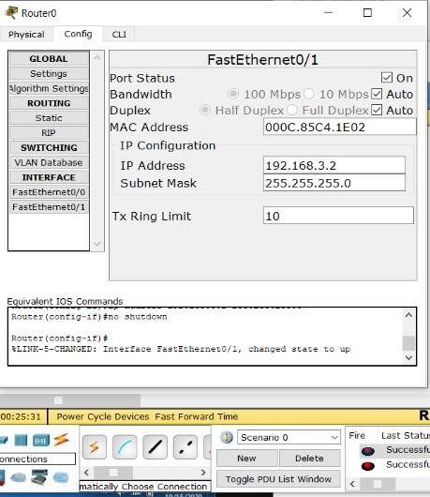

Step 8:
Click on Router1. Go to Config > FastEthernet0/0. Here, add IP Address and On the Port Status.
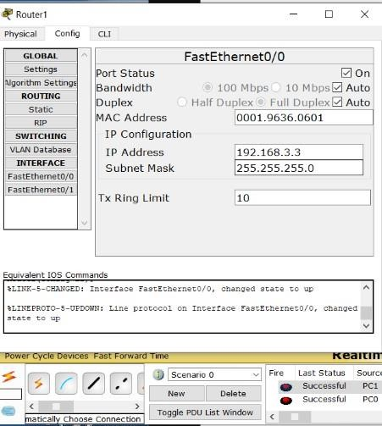

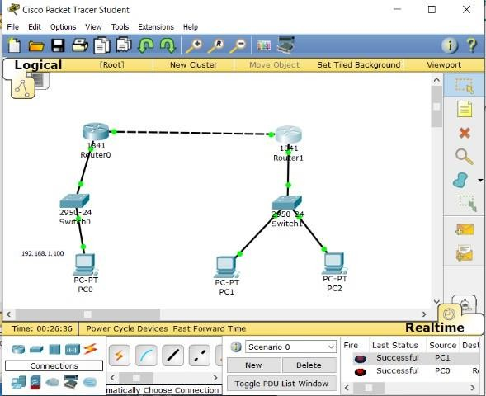

As you can see above, connection is done between both the Routers successfully

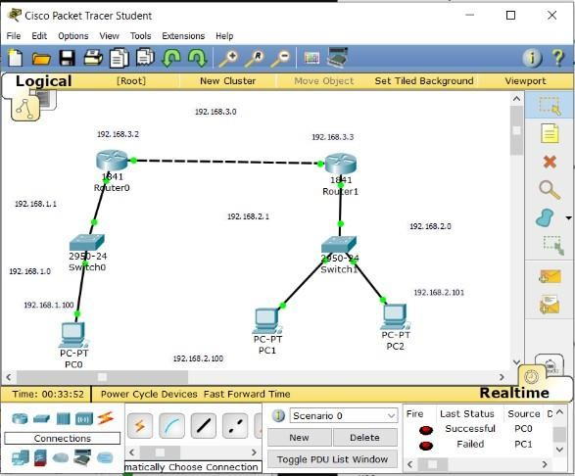.

Step 9:
Click on Router1. Go to Config > RIP.
Here, add the network address to connect router1 with switch1, PC1, PC2 and router0.
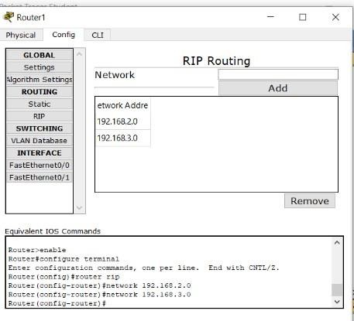

Step 10:
Click on Router0. Go to Config > RIP.
Here, add the network address to connect router0 with switch0, PC0 and router1.

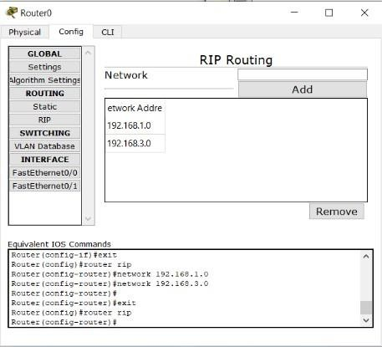

Now, all the connections are done successfully, you can check it by clicking on this symbol

And then, click on any two PCs, you will get the status as successful.

Final Output:
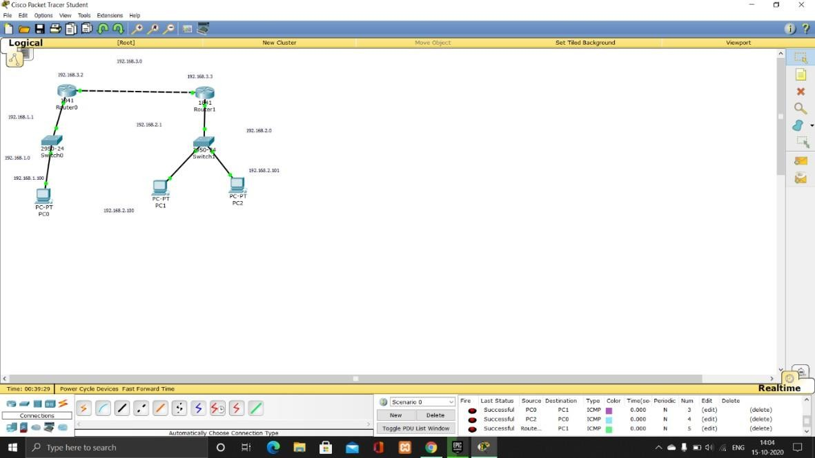
So, Routing Information Protocol is done.
Now, we will start with implementing VLAN.

Steps for implementing VLAN:

Step 11:
Add two PC (PC 3 and PC4) and connect it with switch.
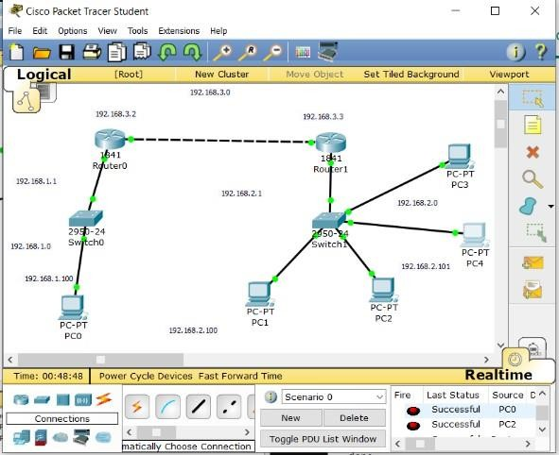

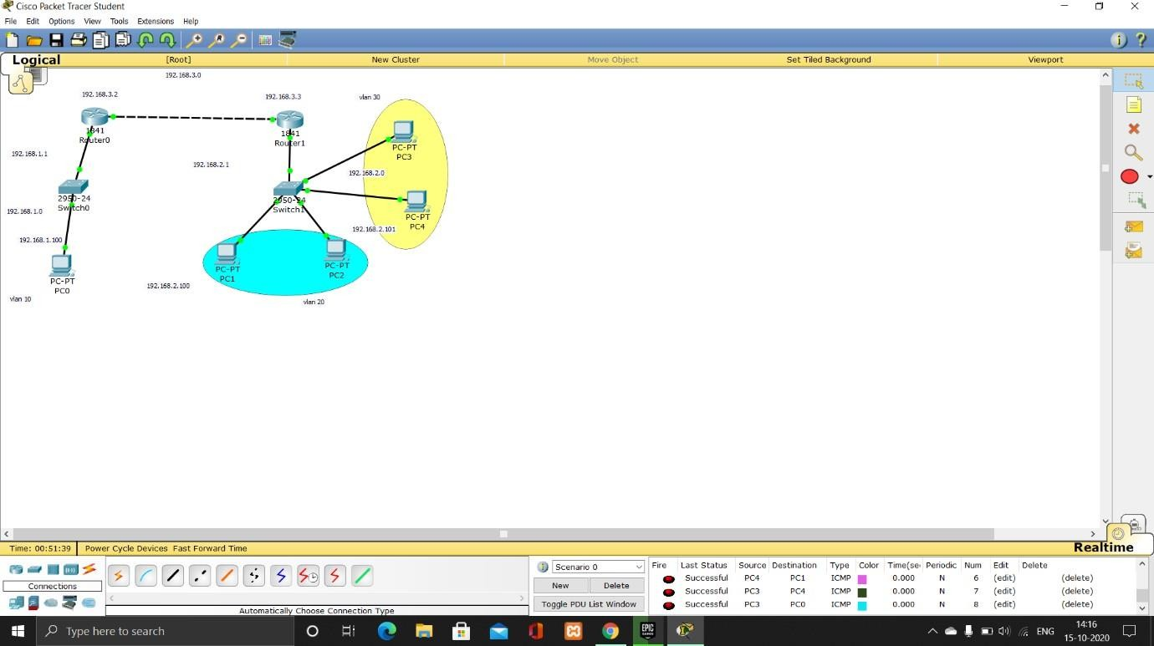

Step 12:
Click on PC3 and go to Desktop > IP Configuration
Add IP Address, as you will add the IP Address, Subnet Mask will be automatically added and displayed.

Add Default Gateway and close the window.
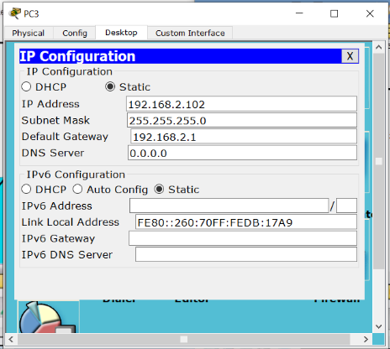

Step 13:
Click on PC3 and go to Desktop > IP Configuration
Add IP Address, as you will add the IP Address, Subnet Mask will be automatically added and displayed.

Add Default Gateway and close the window.
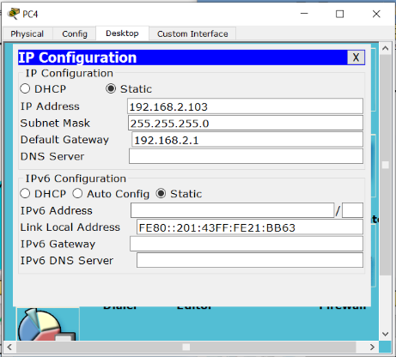

Step 14:
Click on Switch1 and go to CLI Add type the VLAN code – VLAN CODE:
VLAN

enable config t vlan 20
name purchase exit
vlan 30 name sales exit
int fa0/2
switchport access vlan 20 exit
int fa0/3
switchport access vlan 20 exit
int fa0/4
switchport access vlan 30 exit

int fa0/5

switchport access vlan 30 exit

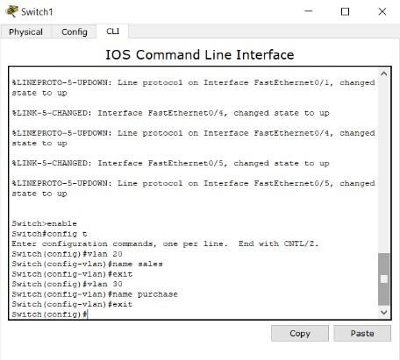
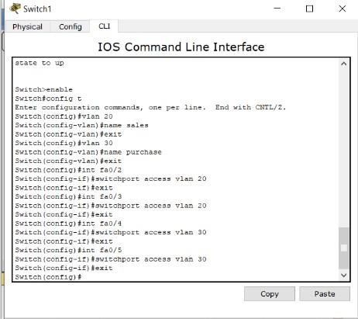

Final Output:
Now, PC1, PC2 are not connected to PC3 and PC4.


Agnel Charities
Fr. C. Rodrigues Institute of Technology, Vashi, Navi-Mumbai Computer Engineering Department

CN Lab Manual
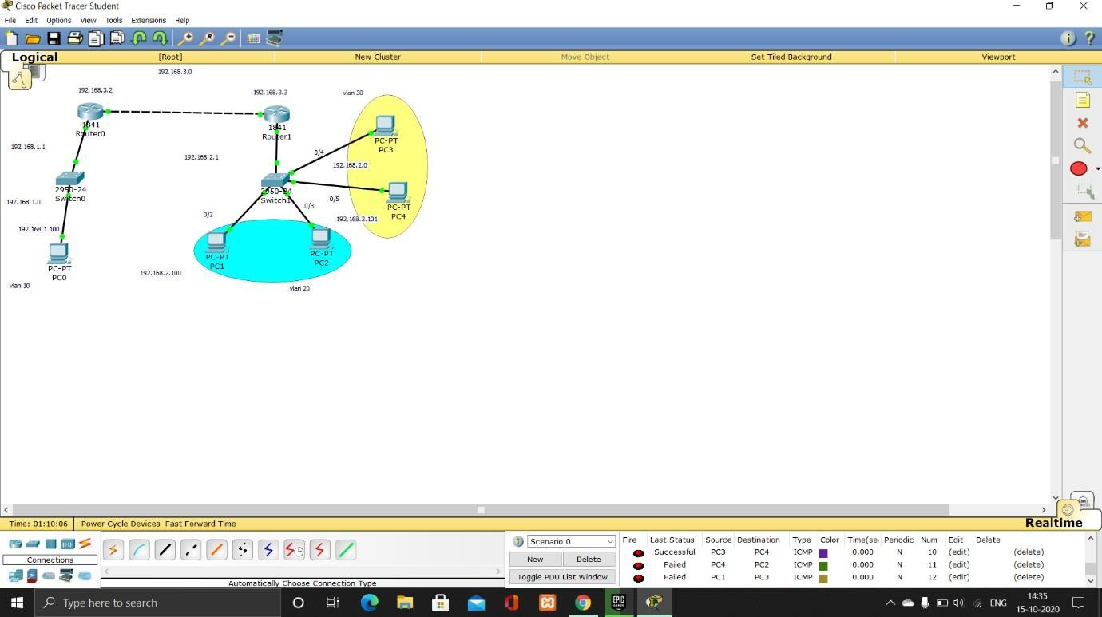

CONCLUSION: Thus, we have successfully implemented VLAN and RIP protocol.

CONCLUSION: Thus we have designed VPN and Configure RIP/OSPF using Packet tracer

Here’s a clear and simple lab-ready explanation for your task:

🧪 Network Discovery using Nmap & MRTG
Network discovery is used to identify active devices, open ports, and running services on a target system or network. Tools like Nmap and MRTG help in analyzing network structure and activity.

🌐 1. Using Nmap (Network Mapper)
Nmap is a powerful tool used to scan hosts and detect open/closed ports along with running services.

🔹 Basic Scan Command:
nmap <target_IP>

🔹 Service & Version Detection:
nmap -sV <target_IP>

🔹 Port States Identified:
- Open → Service is actively running and accepting connections
- Closed → No service is listening on that port
- Filtered → Blocked by firewall or not reachable

📌 Example Output:
PORT STATE SERVICE
22/tcp open ssh
80/tcp open http
443/tcp closed https
135/tcp filtered msrpc
👉 This shows:
- SSH and HTTP services are running
- HTTPS port is closed
- MSRPC is blocked (filtered)

📊 2. Using MRTG (Traffic Monitoring Tool)
MRTG is used to monitor network traffic and visualize bandwidth usage over time.

🔹 Features:
- Graphical representation of network usage
- Monitors router/interface traffic
- Helps detect unusual spikes or congestion
👉 Unlike Nmap, MRTG does not scan ports; it focuses on traffic monitoring.

🎯 Conclusion
Network discovery tools like Nmap and MRTG help in:
- Identifying active hosts in a network
- Detecting open, closed, and filtered ports
- Finding running services on a system
- Monitoring network traffic and performance

If you want, I can also give you exact viva answers + commands + sample output screenshots format for exam writing.

Practical 9

AIM: Write a program to implement socket programming using TCP.

Theory:
Java Socket Programming
- Java Socket programming is used for communication between the applications running on different JRE.
- Java Socket programming can be connection-oriented or connection-less.
- Socket and Server Socket classes are used for connection-oriented socket programming and Datagram Socket and Datagram Packet classes are used for connection-less socket programming.

The client in socket programming must know two information:
  - IP Address of Server, and
  - Port number.
Here, we are going to make one-way client and server communication. In this application, client sends a message to the server, server reads the message and prints it. Here, two classes are being used: Socket and Server Socket.
The Socket class is used to communicate client and server. Through this class, we can read and write message. The Server Socket class is used at server-side. The accept () method of Server Socket class blocks the console until the client is connected. After the successful connection of client, it returns the instance of Socket at server-side.

#Socket class
A socket is simply an endpoint for communications between the machines. The Socket class can be used to create a socket.

#ServerSocket class
The ServerSocket class can be used to create a server socket. This object is used to establish communication with the clients.

Creating Server:
To create the server application, we need to create the instance of ServerSocket class. Here, we are using 6666 port number for the communication between the client and server. You may also choose any other port number. The accept() method waits for the client. If clients connects with the given port number, it returns an instance of Socket.
ServerSocket ss=new ServerSocket(6666);
Socket s=ss.accept();//establishes connection and waits for the client

Creating Client:
To create the client application, we need to create the instance of Socket class. Here, we need to pass the IP address or hostname of the Server and a port number. Here, we are using "localhost" because our server is running on same system.
Socket s=new Socket("localhost",6666);

Code:

MyServer.java file
import java.io.*; import java.net.*; public class MyServer
public static void main(String[] args){ try
{
ServerSocket ss=new ServerSocket(6666); Socket s=ss.accept();//establishes connection DataInputStream dis=new DataInputStream(s.getInputStream()); String str=(String)dis.readUTF(); System.out.println("message= "+str); ss.close();
}
catch(Exception e){System.out.println(e);}
}
}

MyClient.java file
import java.io.*; import java.net.*; public class MyClient
{
public static void main(String[] args)
{
try
{
Socket s=new Socket("localhost",6666);
DataOutputStream dout=new DataOutputStream(s.getOutputStream()); dout.writeUTF("Hello Server");
dout.flush();
dout.close();
s.close();
}catch(Exception e){System.out.println(e);}
}
}

Output:
To execute this program open two command prompts and execute each program at each command prompt as displayed in the below figures.
First run Myserver.java file in terminal/cmd,
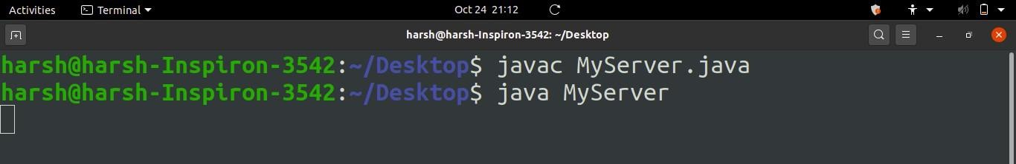

Running MyServer.java

Then in new terminal/cmd run MyClient.java file,
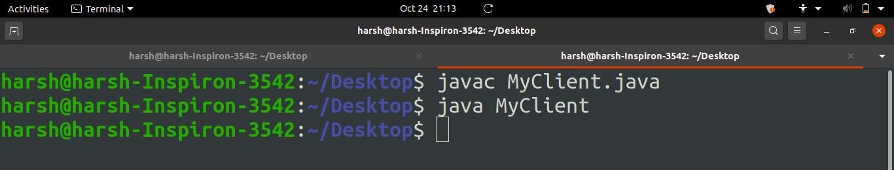
Running MyClient.java
As soon as you run MyClient program a message is sent to server and displayed in MyServer Terminal/CMD as shown below,

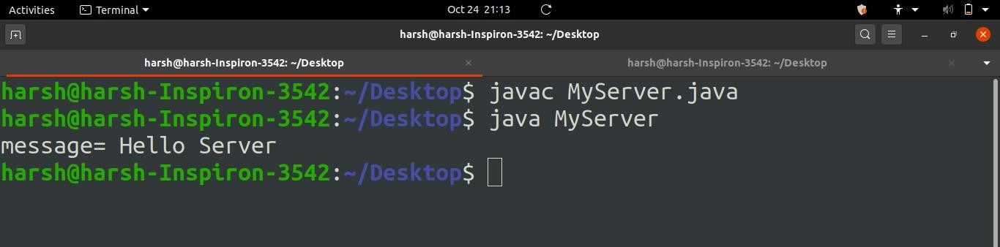Fig.
Message displayed in MyServer after running MyClient

CONCLUSION: So, in this Practical we have successfully understood the concept of Socket Programming and implemented it using Java Programming.

PRACTICAL NO.10

AIM: Perform Remote login using Telnet server

THEORY: THEORY:
Telnet protocol allows you to connect to remote hosts over TCP/IP network. Telnet was developed in 1969. Telnet was initially developed for private use where security was not primary concern. Telnet protocol has serious security issue. Security expert recommend that the use of Telnet for remote login should be discontinued under all normal circumstances.
- Telnet Server
- Telnet Client

Telnet Sever
Telnet server software is installed on remote host. You need to configure it before client can connect with it.

Telnet Client
Telnet client software allows you to connect telnet server. Once telnet client establishes a connection to the remote host, client becomes a virtual terminal, allowing you to communicate with the remote host from your computer.

Security issue with Telnet
- Telnet by default does not encrypt any data sent over the connection.
- Anyone who has access to network device located on the network between the two hosts like router, switch, hub or gateway where Telnet is being used can intercept the packets
passing by and obtain login, password and whatever else is typed with a packet sniffer software.
- Telnet protocol have no implementations that would ensure that communication is carried out between the two hosts is not intercepted in the middle.
- In RHEL Telnet is part of the xinetd daemon.
- Telnet use plain text to transmit password.
- root user is not allowed to connect using Telnet.
- Command-line telnet clients are built into all major operating systems.

IMPLEMENTATION:

Configure Telnet in RHEL 6






Three RPM are required to configure telnet server in linux. xinetd
telnet-server telnet-client

Step 1: Installation of Packages
- Login using root account. Necessary rpm for telnet server is xinetd, telnet-server and

telnet .
# rpm –ivh xinetd-2.3.14-31.e16.X86_64 # rpm –ivh telnet-server-
# rpm –ivh telnet-
- To check whether the package is installed on the system.

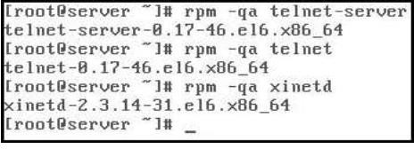

The version numbers of the package should not matter, Red Hat Network (RHN) will always provide you with the latest version of the package.

Step 2: Check Configuration files
Once you have the packages installed, check the /etc/xinetd.d/telnet file


ensure that disable = yes is changed to read disable = no.
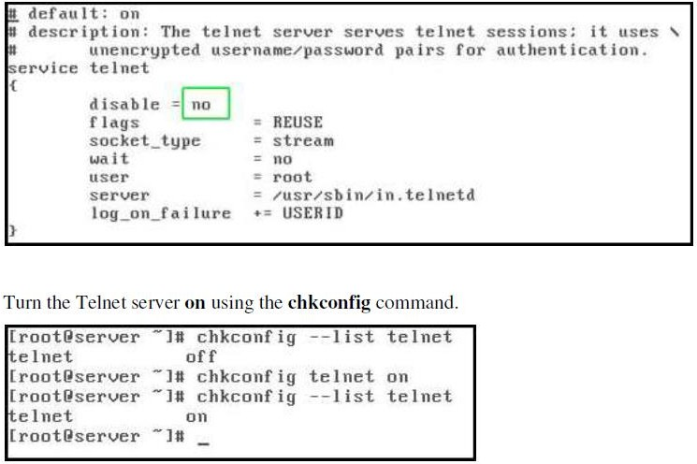

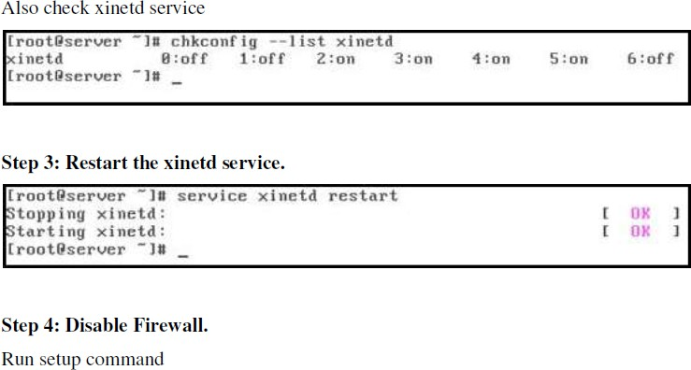

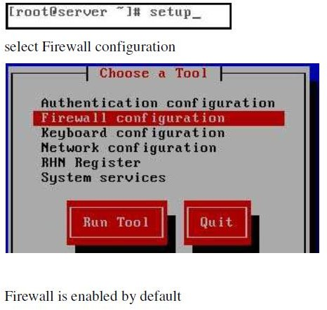

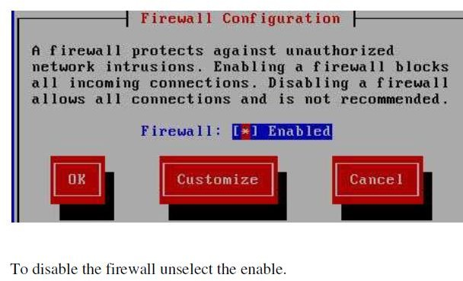

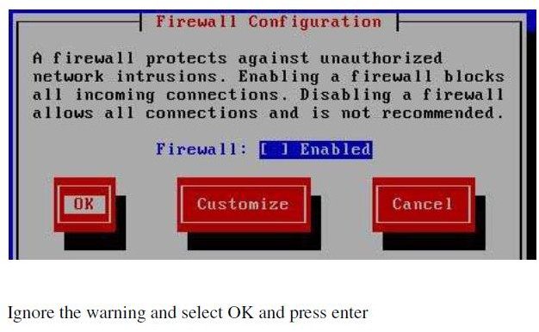

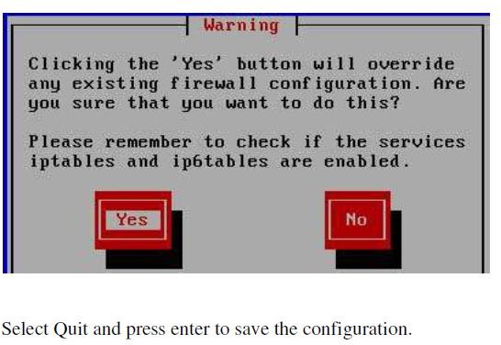
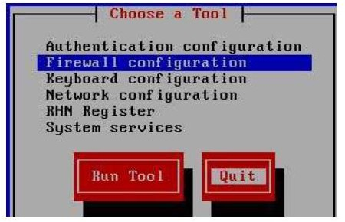

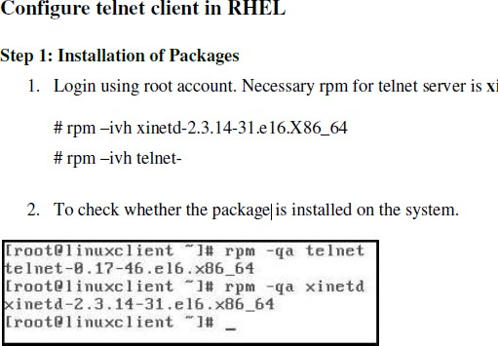

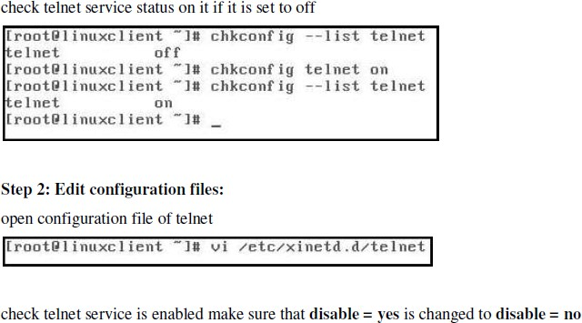

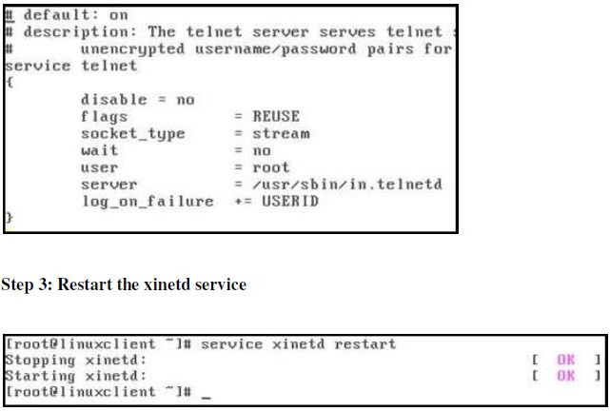

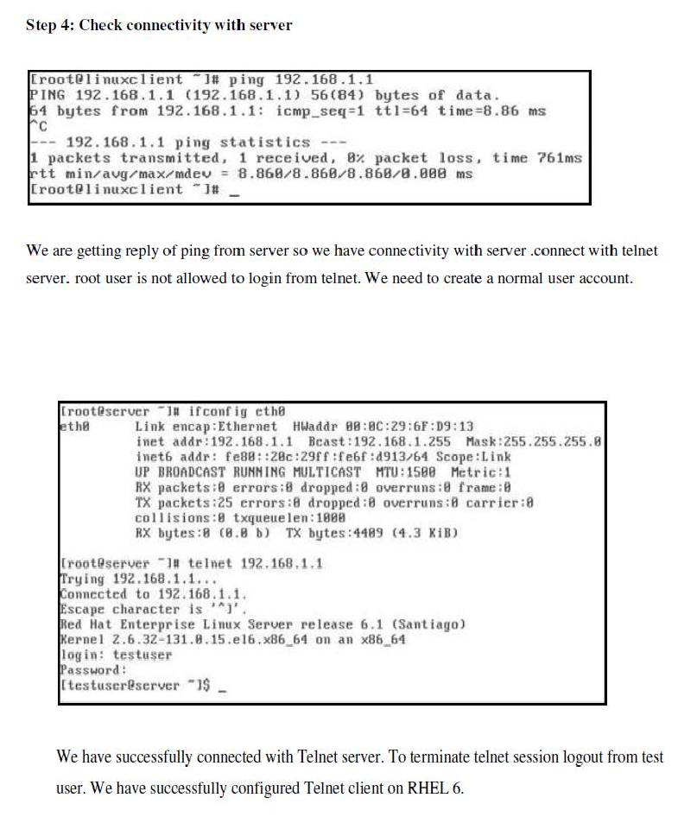
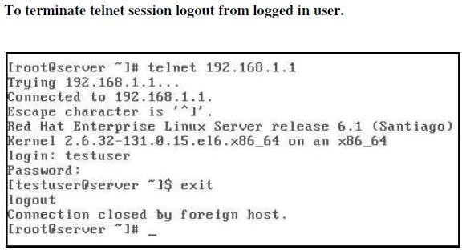

Conclusion –
Telnet is an application protocol used on the Internet or local area networks to provide a bidirectional interactive text-oriented communication facility using a virtual terminal connection. However, telnet by default does not encrypt any data sent over the connection (including passwords), and so it is often feasible to eavesdrop on the communications and use the password later for malicious purposes.

CRC/CHECKSUM: C and Python (SWITCH CASE)
#include <stdio.h>
#include <string.h>

void checksum_binary();
void crc();

int main(){
int choice;
while(1){
printf("\n--Error Detection Techniques--\n");
printf("1. Checksum (Binary input)\n");
printf("2. CRC\n");
printf("3. Exit\n");
printf("Enter your choice (1-3): ");
scanf("%d",&choice);

switch(choice){
case 1:
checksum_binary();
break;
case 2:
crc();
break;
case 3:
printf("\nExiting Program....\n");
return 0;
default:
printf("Invalid choice!\n");
}
}
}

void checksum_binary(){
int n,i,j,carry;
char data[10][20], sum[20], checksum[20], final[20];

printf("Enter number of binary segments: ");
scanf("%d",&n);

printf("Enter binary data (all equal length): \n");
for(i = 0; i < n; i++)
scanf("%s",data[i]);

strcpy(sum,data[0]);

for(i = 1; i < n; i++){
carry = 0;
for(j = strlen(sum)-1; j >= 0; j--){
int bit1 = sum[j]-'0';
int bit2 = data[i][j]-'0';
int temp = bit1 + bit2 + carry;

sum[j] = (temp % 2)+'0';
carry = temp / 2;
}

if(carry == 1){
for(j = strlen(sum)-1; j >= 0; j--){
if(sum[j] == '0'){
sum[j] = '1';
break;
} else {
sum[j] = '0';
}
}
}
}

strcpy(checksum,sum);

for(i = 0; i < strlen(checksum); i++)
checksum[i] = (checksum[i]=='0')?'1':'0';

printf("Generated Checksum: %s\n",checksum);

strcpy(final,sum);
carry = 0;

for(j = strlen(final)-1; j >= 0; j--){
int bit1 = final[j]-'0';
int bit2 = checksum[j]-'0';
int temp = bit1 + bit2 + carry;

final[j] = (temp % 2)+'0';
carry = temp / 2;
}

if(carry == 1){
for(j = strlen(final)-1; j >= 0; j--){
if(final[j] == '0'){
final[j] = '1';
break;
} else {
final[j] = '0';
}
}
}

printf("Final sum at receiver's end is: %s\n", final);

int error = 0;
for(i = 0; i < strlen(final); i++){
if(final[i] != '1'){
error = 1;
break;
}
}

if(error == 0)
printf("No error\n");
else
printf("Error detected\n");
}

void crc(){
char data[100], divisor[100], remainder[100], received[100];
int i, j, data_len, div_len, rec_len;

printf("Enter data: ");
scanf("%s", data);

printf("Enter divisor: ");
scanf("%s", divisor);

data_len = strlen(data);
div_len = strlen(divisor);

// Append zeros
for(i = 0; i < div_len - 1; i++)
data[data_len + i] = '0';
data[data_len + div_len - 1] = '\0';

strcpy(remainder, data);

// CRC division (sender side)
for(i = 0; i <= data_len - 1; i++){
if(remainder[i] == '1'){
for(j = 0; j < div_len; j++){
remainder[i + j] =
(remainder[i + j] == divisor[j]) ? '0' : '1';
}
}
}

printf("CRC Remainder: ");
for(i = data_len; i < data_len + div_len - 1; i++)
printf("%c", remainder[i]);

printf("\nCodeword: ");
for(i = 0; i < data_len; i++)
printf("%c", data[i]);
for(i = data_len; i < data_len + div_len - 1; i++)
printf("%c", remainder[i]);
printf("\n");

// -------- Receiver Side --------
printf("\nEnter received codeword: ");
scanf("%s", received);

rec_len = strlen(received);
strcpy(remainder, received);

// CRC division (receiver side)
for(i = 0; i <= rec_len - div_len; i++){
if(remainder[i] == '1'){
for(j = 0; j < div_len; j++){
remainder[i + j] =
(remainder[i + j] == divisor[j]) ? '0' : '1';
}
}
}

int error = 0;
for(i = rec_len - div_len + 1; i < rec_len; i++){
if(remainder[i] != '0'){
error = 1;
break;
}
}

if(error == 0)
printf("No Error Detected\n");
else
printf("Error Detected\n");
}
🧪 SAMPLE RUN
--Error Detection Techniques--
1. Checksum (Binary input)
2. CRC
3. Exit
Enter your choice (1-3): 2

Enter data: 1101
Enter divisor: 1011
CRC Remainder: 001

Codeword: 1101001

Enter received codeword: 1101001
No Error Detected

❌ SAMPLE WITH ERROR
--Error Detection Techniques--
1. Checksum (Binary input)
2. CRC
3. Exit
Enter your choice (1-3): 2

Enter data: 1101
Enter divisor: 1011
CRC Remainder: 001

Codeword: 1101001

Enter received codeword: 1101101
Error Detected

🧪 CHECKSUM SAMPLE
--Error Detection Techniques--
1. Checksum (Binary input)
2. CRC
3. Exit
Enter your choice (1-3): 1

Enter number of binary segments: 3
Enter binary data (all equal length):
1100
1010
1001

Generated Checksum: 0010
Final sum at receiver's end is: 1111
No error

PYTHON
def binary_add(a, b):
result = ""
carry = 0

for i in range(len(a)-1, -1, -1):
total = int(a[i]) + int(b[i]) + carry
result = str(total % 2) + result
carry = total // 2

if carry:
result = binary_add(result, "0"*(len(result)-1) + "1")

return result

# ---------------- CHECKSUM ----------------
def checksum_binary():
n = int(input("Enter number of binary segments: "))
data = []

print("Enter binary data (all equal length):")
for _ in range(n):
data.append(input())

sum_val = data[0]

for i in range(1, n):
sum_val = binary_add(sum_val, data[i])

checksum = ''.join('1' if bit == '0' else '0' for bit in sum_val)

print("Generated Checksum:", checksum)

final = binary_add(sum_val, checksum)

print("Final sum at receiver's end:", final)

if all(bit == '1' for bit in final):
print("No error")
else:
print("Error detected")

# ---------------- CRC ----------------
def xor(a, b):
result = ""
for i in range(1, len(b)):
result += '0' if a[i] == b[i] else '1'
return result

def crc_compute(data, divisor):
n = len(divisor)
temp = data[0:n]

for i in range(n, len(data)):
if temp[0] == '1':
temp = xor(divisor, temp) + data[i]
else:
temp = xor('0'*n, temp) + data[i]

if temp[0] == '1':
temp = xor(divisor, temp)
else:
temp = xor('0'*n, temp)

return temp

def crc():
data = input("Enter data: ")
divisor = input("Enter divisor: ")

data_padded = data + '0'*(len(divisor)-1)

remainder = crc_compute(data_padded, divisor)

print("CRC Remainder:", remainder)

codeword = data + remainder
print("Codeword:", codeword)

received = input("\nEnter received codeword: ")

rem = crc_compute(received, divisor)

if set(rem) == {'0'}:
print("No Error Detected")
else:
print("Error Detected")

# ---------------- MAIN MENU ----------------
while True:
print("\n--Error Detection Techniques--")
print("1. Checksum (Binary input)")
print("2. CRC")
print("3. Exit")

choice = int(input("Enter your choice (1-3): "))

if choice == 1:
checksum_binary()
elif choice == 2:
crc()
elif choice == 3:
print("\nExiting Program....")
break
else:
print("Invalid choice!")

✅ 1. CHECKSUM PROGRAM

🔹 C Code (Checksum Only)
#include <stdio.h>
#include <string.h>
int main(){
int n,i,j,carry;
char data[10][20], sum[20], checksum[20], final[20];
printf("Enter number of binary segments: ");
scanf("%d",&n);
printf("Enter binary data (all equal length): \n");
for(i = 0; i < n; i++)
scanf("%s",data[i]);
strcpy(sum,data[0]);
for(i = 1; i < n; i++){
carry = 0;
for(j = strlen(sum)-1; j >= 0; j--){
int bit1 = sum[j]-'0';
int bit2 = data[i][j]-'0';
int temp = bit1 + bit2 + carry;
sum[j] = (temp % 2)+'0';
carry = temp / 2;
}
if(carry == 1){
for(j = strlen(sum)-1; j >= 0; j--){
if(sum[j] == '0'){
sum[j] = '1';
break;
} else {
sum[j] = '0';
}
}
}
}
strcpy(checksum,sum);
for(i = 0; i < strlen(checksum); i++)
checksum[i] = (checksum[i]=='0')?'1':'0';
printf("Generated Checksum: %s\n",checksum);
strcpy(final,sum);
carry = 0;
for(j = strlen(final)-1; j >= 0; j--){
int bit1 = final[j]-'0';
int bit2 = checksum[j]-'0';
int temp = bit1 + bit2 + carry;
final[j] = (temp % 2)+'0';
carry = temp / 2;
}
if(carry == 1){
for(j = strlen(final)-1; j >= 0; j--){
if(final[j] == '0'){
final[j] = '1';
break;
} else {
final[j] = '0';
}
}
}
printf("Final sum at receiver's end is: %s\n", final);
int error = 0;
for(i = 0; i < strlen(final); i++){
if(final[i] != '1'){
error = 1;
break;
}
}
if(error == 0)
printf("No error\n");
else
printf("Error detected\n");
return 0;
}

🔹 Python Code (Checksum Only)
def binary_add(a, b):
result = ""
carry = 0
for i in range(len(a)-1, -1, -1):
total = int(a[i]) + int(b[i]) + carry
result = str(total % 2) + result
carry = total // 2
if carry:
result = binary_add(result, "0"*(len(result)-1) + "1")
return result
n = int(input("Enter number of binary segments: "))
data = []
print("Enter binary data:")
for _ in range(n):
data.append(input())
sum_val = data[0]
for i in range(1, n):
sum_val = binary_add(sum_val, data[i])
checksum = ''.join('1' if bit == '0' else '0' for bit in sum_val)
print("Generated Checksum:", checksum)
final = binary_add(sum_val, checksum)
print("Final sum at receiver's end:", final)
if all(bit == '1' for bit in final):
print("No error")
else:
print("Error detected")

✅ 2. CRC PROGRAM

🔹 C Code (CRC Only)
#include <stdio.h>
#include <string.h>
int main(){
char data[100], divisor[100], remainder[100], received[100];
int i, j, data_len, div_len, rec_len;
printf("Enter data: ");
scanf("%s", data);
printf("Enter divisor: ");
scanf("%s", divisor);
data_len = strlen(data);
div_len = strlen(divisor);
for(i = 0; i < div_len - 1; i++)
data[data_len + i] = '0';
data[data_len + div_len - 1] = '\0';
strcpy(remainder, data);
for(i = 0; i <= data_len - 1; i++){
if(remainder[i] == '1'){
for(j = 0; j < div_len; j++){
remainder[i + j] =
(remainder[i + j] == divisor[j]) ? '0' : '1';
}
}
}
printf("CRC Remainder: ");
for(i = data_len; i < data_len + div_len - 1; i++)
printf("%c", remainder[i]);
printf("\nCodeword: ");
for(i = 0; i < data_len; i++)
printf("%c", data[i]);
for(i = data_len; i < data_len + div_len - 1; i++)
printf("%c", remainder[i]);
printf("\n");
printf("\nEnter received codeword: ");
scanf("%s", received);
rec_len = strlen(received);
strcpy(remainder, received);
for(i = 0; i <= rec_len - div_len; i++){
if(remainder[i] == '1'){
for(j = 0; j < div_len; j++){
remainder[i + j] =
(remainder[i + j] == divisor[j]) ? '0' : '1';
}
}
}
int error = 0;
for(i = rec_len - div_len + 1; i < rec_len; i++){
if(remainder[i] != '0'){
error = 1;
break;
}
}
if(error == 0)
printf("No Error Detected\n");
else
printf("Error Detected\n");
return 0;
}

🔹 Python Code (CRC Only)
def xor(a, b):
result = ""
for i in range(1, len(b)):
result += '0' if a[i] == b[i] else '1'
return result
def crc(data, divisor):
n = len(divisor)
temp = data[0:n]
for i in range(n, len(data)):
if temp[0] == '1':
temp = xor(divisor, temp) + data[i]
else:
temp = xor('0'*n, temp) + data[i]
if temp[0] == '1':
temp = xor(divisor, temp)
else:
temp = xor('0'*n, temp)
return temp
data = input("Enter data: ")
divisor = input("Enter divisor: ")
data_padded = data + '0'*(len(divisor)-1)
remainder = crc(data_padded, divisor)
print("CRC Remainder:", remainder)
codeword = data + remainder
print("Codeword:", codeword)
received = input("Enter received codeword: ")
rem = crc(received, divisor)
if set(rem) == {'0'}:
print("No Error Detected")
else:
print("Error Detected")

